**Fancy Restaurant Location - Narrowing Michigan Location**

GitHub Reference: https://github.com/sforsyth089/Coursera_Capstone

 By: Stacy Forsyth, 12/15/2020

**Introduction and Background**

**Introduction** A chef has saved the money and would like to open a new restaurant somewhere in Michigan. The menu will focus on steak and seafood. The chef plans to have an upscale steak house restaurant and would like to attract appropriate clientele. The meals will be in above average cost ranges with a variety of innovative side dishes and desserts. The chef thinks downtown Detroit will be the best location, however, would like to run analysis on some data through the whole state of MI in order to be sure to pick the best location. The chef wants to ensure there will be enough business coming in and not too much competition. Therefore, average income of nearby cities will be analyzed.



**Business Question** The business question: Is downtown Detroit a good location for a restaurant? If so, which places downtown seem the best? If not downtown, what other location seems better?

**Target Audience** The chef with ultimate decision-making power and her group of investors. This data will allow the chef and her investors to make the best decision before moving forward.

**Data Description**

**Data Sources** Foursquare <https://foursquare.com/> The venue and location data will be used to assess the best place to open. For example, are similar venues nearby? That would help show clientele is in the area. Location information will help answer where exactly to rent a building to open the restaurant. Foursquare data can also be used to access reviews in order to do some other planning before opening based on client feedback in that area. Based on popularity of downtown restaurants we are sure we can get enough venue information which is a feature of Foursquare. For more information on how Foursquare data can be used, check out this article: <https://www.eater.com/2015/4/24/8486279/restaurant-recommendation-apps-foursquare-algorithms>

Zip Code data - <https://public.opendatasoft.com/explore/dataset/us-zip-code-latitude-and-longitude/export/> This open source data was downloaded and limited to Michigan, USA. Added to my GitHub for reference. Will help to make maps and determine locations. In this GitHub: <https://github.com/sforsyth089/Coursera_Capstone/blob/main/MI%20Zip%20Codes%20Lat%20Long.csv>

Top 25 Wealthiest Cities in MI: <https://www.zipdatamaps.com/economics/income/agi/state/wealthiest-zipcodes-in-michigan> will be used to determine wealth nearby. Has zip code to link to the zip code table. In this GitHub: <https://github.com/sforsyth089/Coursera_Capstone/blob/main/Wealthiest%20Neighborhoods%20in%20MI.csv>

**Methodology**

 I used Anaconda Navigator and Python.  Within Python, I used Folium for mapping the area in Michigan.  First, I found the data sets listed above.  Then I cleaned them into a table of only the wealthy areas in MI.

*Refer to GitHub Code here:*

https://github.com/sforsyth089/Coursera_Capstone

K means clustering was used to see where there are groups of areas together to help me visualize where I should put a location.  This was the best machine learning for me to get started.

Finally I did a little reading of articles/trends online to supplement my analytic research to come to a collusion.

Much of the work involves taking the data and cleaning into a usable data frame.  Then creating a map in Folium and running K means.

Final Data Frame to run K means on:

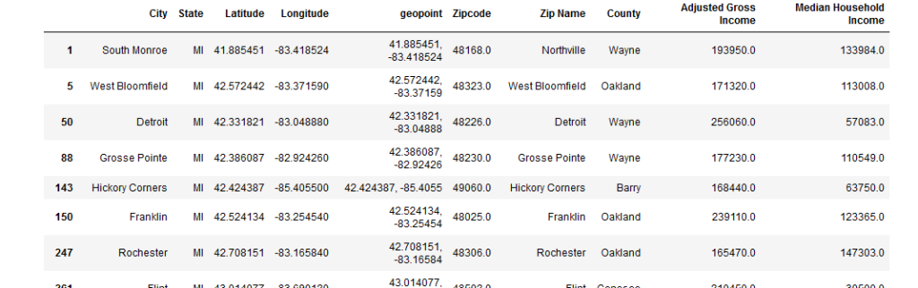

**Results**

Once all of the above was complete (more details in GitHub on each step), I could see the K means clustering that occurred.  The red dots are in the Traverse City area of MI. A new and growing area, but in winter much fewer people in town and we want the restaurant open year-round.

The main clustering is in South East Michigan.

[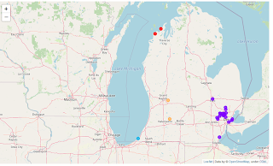](https://1.bp.blogspot.com/-hSYOFoGIQTw/X9kwxZivTkI/AAAAAAAAAz4/NiJ1-EvFko4YU1u8Rd6mu1IQgJ-Wwhp1gCLcBGAsYHQ/s994/ResultofKMeansClusteringAnalysis.png)

I zoom in on the map for Detroit area where we are thinking.

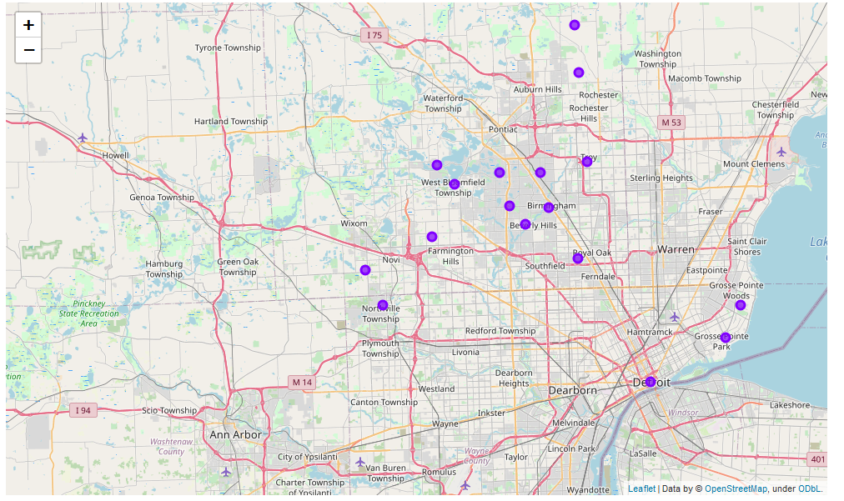

More clustering is occurring in Oakland County area of Michigan.

**Discussion**

Though, initially I thought Detroit for location, I see much more opportunity in the Oakland County area.  I know that some up-north tourist spots are trending however the winter can be very snowy and most business arrives in the summer.

I find an outside article saying that Oakland County is growing. [https://www.mlive.com/public-interest/2020/06/latest-census-data-shows-michigans-fastest-growing-and-shrinking-communities.html](https://www.blogger.com/)  This helps me and the investors look more closely at the following cities: Bloomfield Hills, West Bloomfield, Birmingham, Beverly Hills, or Royal Oak.

**Conclusion**

We have used data science to thoughtfully narrow down where in MI to locate our restaurant. We will now focus on the Oakland County area.  We have more to do like visit sites and narrow down the cities even more, but we are off to a good start and this exercise was productive!